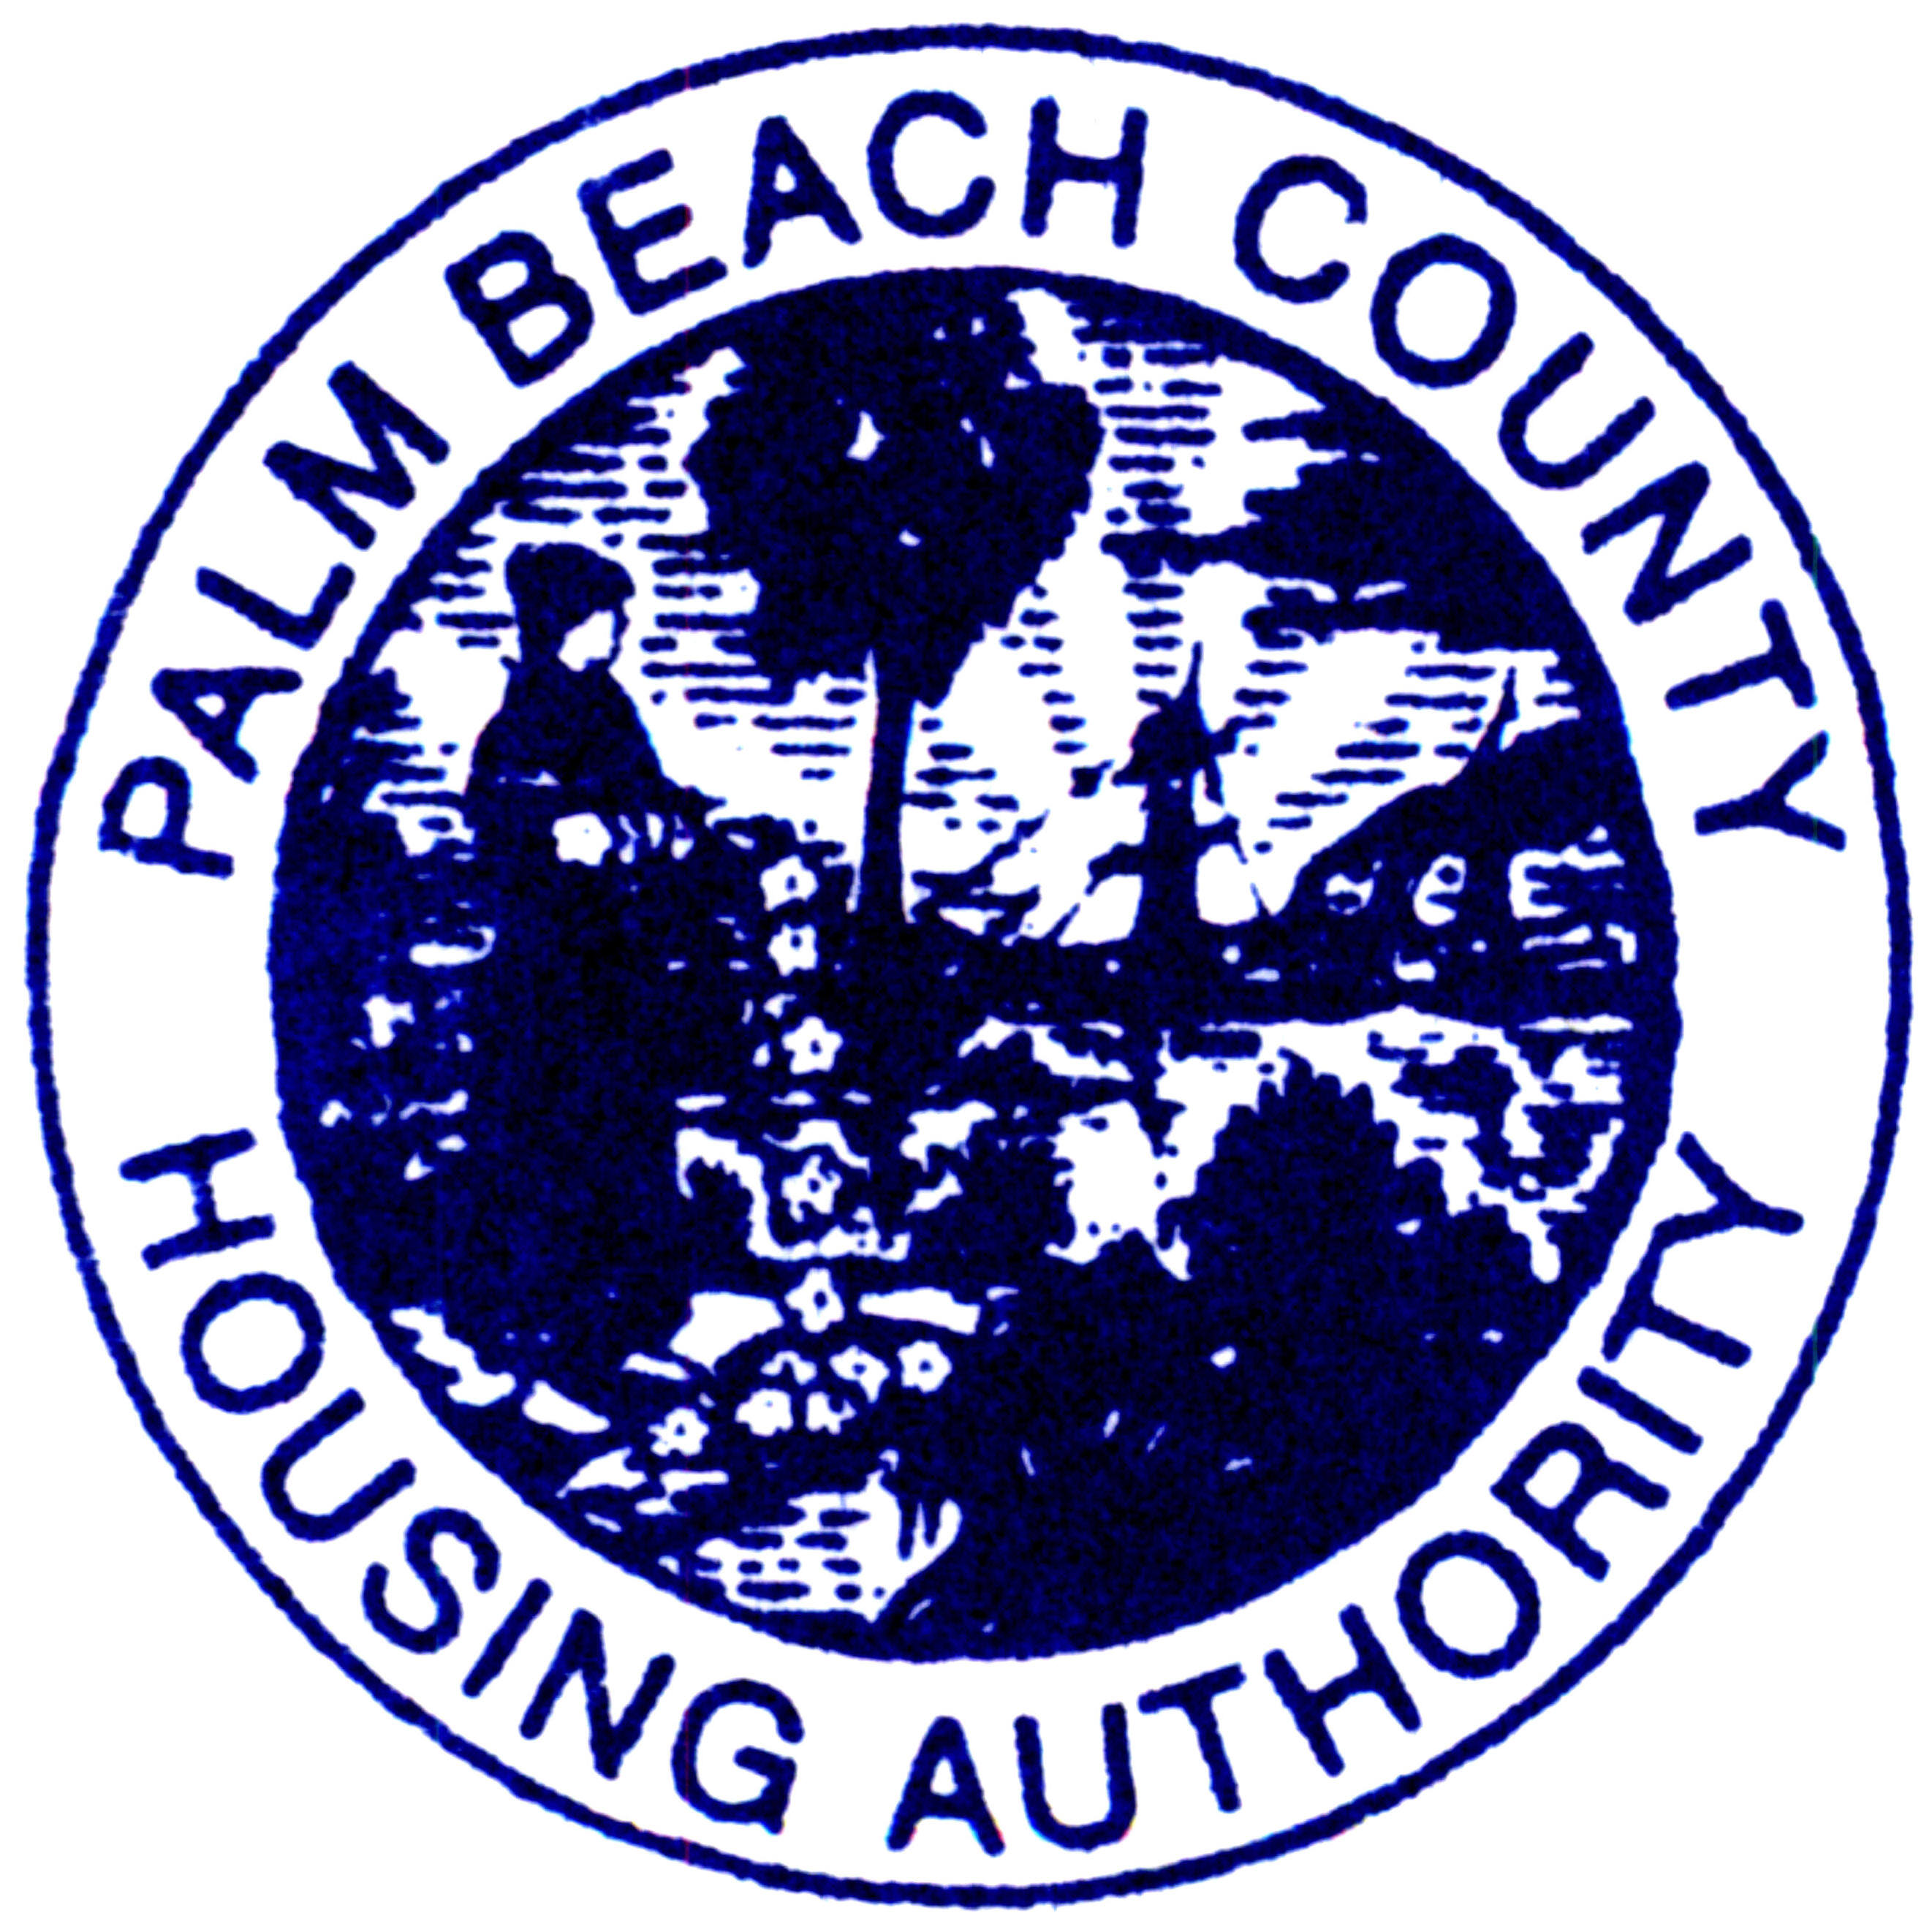
Palm Beach County Housing Authority

Housing Choice Voucher (Section 8)
Waiting List Open for On Line Applications

The Palm County Housing Authority (PBCHA) will open its Housing Choice Voucher (Section 8) Waiting List on September 8th 2011. Applications will be available online at www.pbchafl.org on September 8th 2011 at 12:01 A.M. Interested applicants must go to this website to complete an application. No paper applications are available. Do Not come to the housing authority offices; this process is limited to an on line, automated process. You may access the website and complete your application at any computer with internet access.
Applicants may only submit one application per family. Please Note, applications will not be available before September 8th 2011.
The application process will end on Thursday September 22, at 11:59 P.M. Applications submitted after this time will not be accepted.
To complete the application on line you must have the following information with you.

- Full names of all family members;
- Date of birth of family members;
- Social Security numbers for ALL family members;
- Current address/zip code;
- Telephone/cell number;
- Total Family Gross Income per year.
If you do not provide the above information your application will not be processed.
After the application end date, five thousand (5,000) applications will be randomly assigned a number utilizing a lottery system and applicants will be placed on the waiting list in order of the assigned number, from 1 to 5000. Beginning September 28th, please check the website www.pbchafl.org to find out if you were assigned a number.
If you need additional information or you are a person with a handicap, disability, or a hearing impairment and need assistance in completing the application, please advise us of your needs by calling 561-684-0278 extension 255 and leaving a message. If you need TTY services in English please call 1-800-955-8771 and for Spanish 1-877-955-8773.

